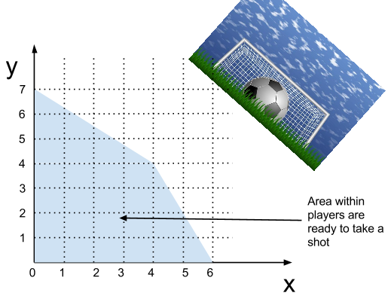 | There are a few players on a team who are ready to take a shot at goal.  The shaded area shows where the players are who are ready to take a shot are (players on the edge are in).  We need to use a bit of mathematics to work out which of these players is the best one to take the shot.  For each of the players below, locate them on the grid above, and write if they are in or out of the area shaded.
Are you in our out??
Player | Location | In or out? | Success (using formula) (show calculation)
David | (4, 4)
Ronaldo | (6, 4)
Wayne | (0, 7)
Roberto | (2, 6)
Paul | (3, 4)
Gary | (6, 0)

The success score (S) of a player taking a shot at goal IF THEY ARE IN THE AREA can be determined using this formula:
S = 3x + 2y

So if Franz was located at (1, 3) which is in the area, then his success score would be 3 x 1 + 2 x 3 = 9
For the players that are in the area, work out their success scores for taking a shot at goal using the formula.

The best person to take the shot is the person with the highest success score.

Who is this person?

Who were the only players worth checking the success score for and why?

Team selections

A coach of a league team is trying to determine who should be in the team and who the captain should be.  He has the following criteria for who should be in the team:  - Weight $≥$ 90 kg [their weight has to be at least 90 kg]  - Height $≤$ 185 cm [their height can be 185 cm at the max]  To decide who should be the captain, he will use the following formula:  - C = 4t + 2p  - C is the captain score, t is the number of tests played and p is the number of points scored | 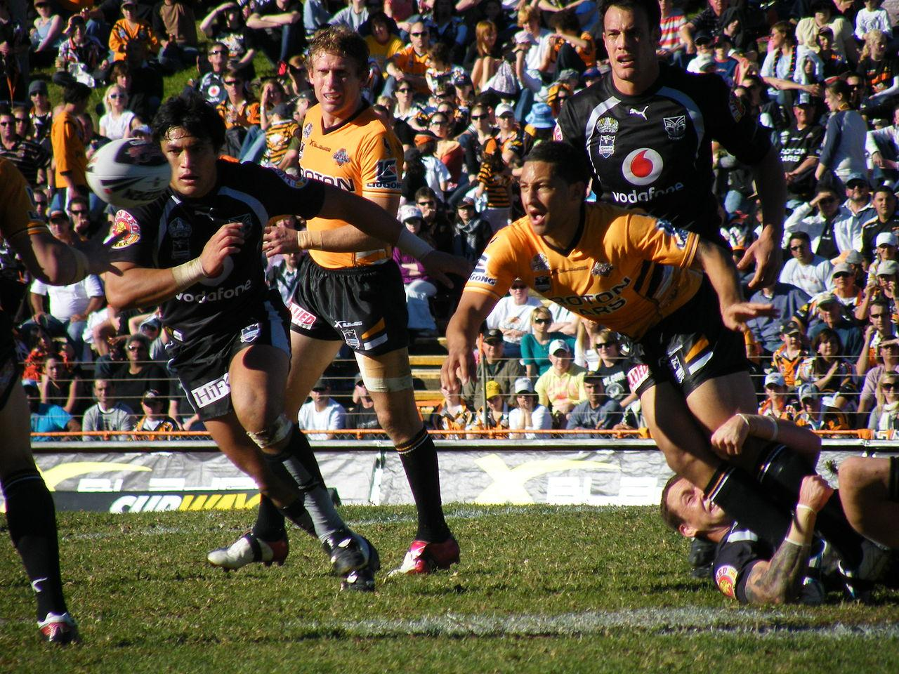

Example: Would Josh Hoffman make the team? What would his captain score be?
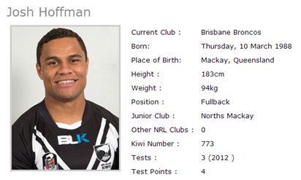 | Yes  He would make the team, because his weight is greater than 90kg (he weighs 94kg) and his height is less than 185cm (he is 183cm tall).  Captain score  He has played 3 tests and scored 4 points.  The captain score formula is C = 4t + 2p  So his captain score is 4 x 3 + 2 x 4 = 20

For the players below, check if they would make the team. If they would make the team, check their captain score.

Player | Weight | Height | No. of tests | Points scored | In or out? | Captain score (show working)
Matthew | 95kg | 178cm | 3 | 2
Ben | 88kg | 192cm | 1 | 0
Latu | 104kg | 182cm | 8 | 24
Simon | 110kg | 184cm | 10 | 6
Daniel | 91kg | 165cm | 20 | 8
Lolo | 98kg | 174cm | 12 | 0
Manu | 85kg | 169cm | 4 | 14

Who should be made the team captain and why?

Finding the best solution

The area shaded on this graph shows all the possible combinations of how much time a student could spend studying and reading books.  (10, 12) means they can spend 10 minutes studying and 12 minutes reading books.  The area is where it is because there are constraints (limitations) on both how much free time the student has to spend reading books and studying, and how much their parents want them to spend reading books and studying.  The student know that doing a combination of both studying and reading books will improve her chances of doing well at school. | 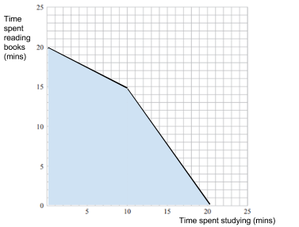

Mark these points on the graph: (0, 20) (10, 15) (20, 0)

Write these points in words (what do they represent):

(0, 20) =

(10, 15) =

(20, 0) =

The student needs to decide which of these combinations is the best one to do to improve her chances of doing well at school.

The formula she will use is: A = 3x + 2y
A is the achievement score x is the time spent studying y is the time spent reading books

Complete the table below for the three combinations above:
x (number of minutes spent studying) | y (number of minutes spent reading) | A (achievement score = 3x + 2y)  Show working!

What is the best combination for this student?

A parent has to decide how many minutes to spend with their daughter (x) and how many minutes to spend with their son (y) [per day].  The limitations on their time are shown in the graph.  They know the key solutions will be based on trying to make the time spent with each child as large as possible.  To decide the best way to spend their time, they will use a formula P = 2x + 3y. The want P to be as big as possible.  How many minutes should they spend with each child to maximise P? | 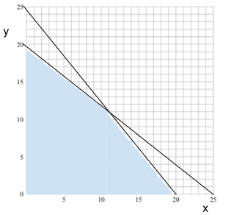

Sally wants to sell her house, and has to decide how many hours to spend renovating the house (x) and how many hours to spend marketing her house on the internet (y).  The limitations on their time are shown in the graph.  They know the key solutions will be based on trying to make the time spent doing either activity as large as possible.  To decide the best way to spend their time, they will use a formula S = 500x + 200y. The want S to be as big as possible.  How many hours should they spend renovating the house and marketing the house to maximise $S? | 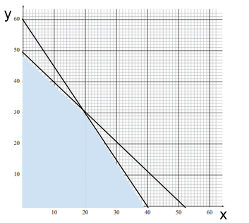

Find the area of possible solutions, and the key solutions to consider

The inequality x + y $≤$ 20 means all the combinations of x and y that add up to anything less than or equal to 20.  For example, if x = 2 and y = 5, then 2 + 5 = 7. This is less than 20, so is a possible combination.  To show all the possible combinations, we shade the area where they are. This is the shaded area shown on the graph. It is all the points below the line.  To get this area, we mark off a value on the x-axis (the x-intercept) and a value on the y-axis (the y-intercept) and draw a line between them. We then shade below this line.  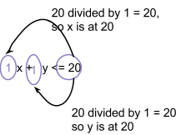 | 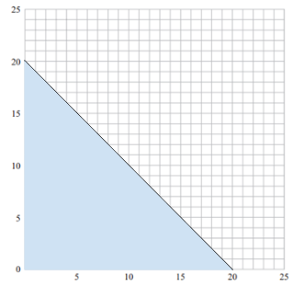  Add 2x + 5y $≤$50 to the graph  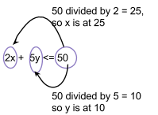

Find the region of all the possible combinations/solutions by drawing just the line for each of the inequalities, and then shading the area they have in common. Then find the key solutions to consider (see example below):
Example: x + y $≤$ 15 and 2x + 3y $≤$ 36  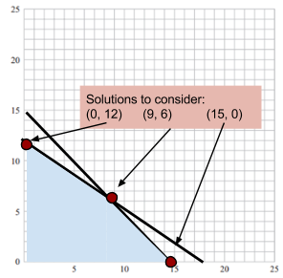 | 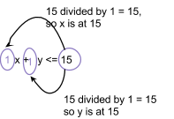  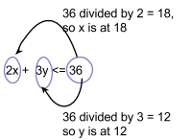

Sketch the area in common to both  x + y $≤$ 20 and 2x + 4y $≤$ 48  and label the key solutions to consider.  HINT:  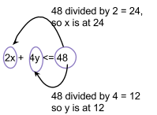 | 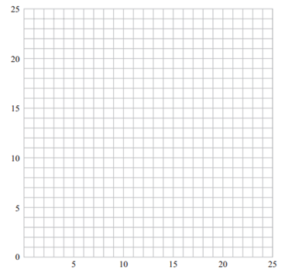
Sketch the area in common to both

x + y $≤$ 18 and 2x + 4y $≤$ 40

and label the key solutions to consider.
Sketch the area in common to both

20x + 30y $≤$ 360 and 200x + 400y $≤$ 4000

and label the key solutions to consider.

Combining skills

Example:

A teacher has to decide how many hours to spend sleeping (x) and how many hours to spend writing reports (y).

The limitations on their time are given below:

x + 2y $≤$ 16 and 3x + 2y $≤$ 36

To decide how to spend their time, they will use a formula P = 6x + 5y.
The want P to be as big as possible.

How many hours should they spend sleeping and writing reports to maximise P?

(1) Find the area of possible solutions and label the key solutions.  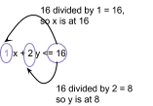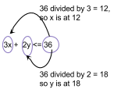  (2) Make a table of the key solutions and check them in the formula.  Key solutions x y P = 6x + 5y  (0, 8) 0 8 6 x 0 + 5 x 8 = 40  (10, 3) 10 3 6 x 10 + 5 x 3 = 75  (12, 0) 12 0 6 x 12 + 5 x 0 = 72  (3) Choose the combination/solution that gives the highest value for the formula and write the answer in words.  The best solution is for the teacher to spend 10 hours sleeping and 3 hours writing reports. | 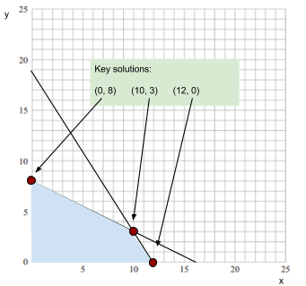

Practice question 1

A coach has to decide how many hours to spend with the team training (x) and how many hours to spend analysing videos of their past games (y).

The limitations on their time are given below:

x + 4y $≤$ 20 and 5x + 2y $≤$ 40

To decide how to spend their time, they will use a formula W = 20x + 15y. The want W to be as big as possible.

How many hours should they spend training with the team and watching past games to maximise W?

Practice question 2

A company has to decide how many people to send on a training course (x) and how many people to send to a resort (y).  The limitations are given below:  200x + 300y $≤$ 12000 and x + y $≤$ 40  To decide how many to send to each, they will use a formula R = x + 2y. The want R to be as big as possible.  How many people should they send on a training course and how many people should they send to a resort to maximise R? | 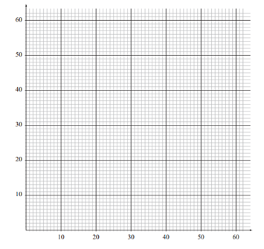

Writing inequations

Word examples:  If x was the number of hours you could spend sleeping each day, then you could write:  x $≤$ 24  which means the number of hours you can sleep is any number less than, or equal to, 24.  x $≥$ 8  would mean you should sleep at least 8 hours.  If x was how many mini-pies you can have and y was how many mini-sandwiches you can have, then:  x + y $≤$ 4  would mean that together (combining these amounts) you can not have any more than 4 mini-pies and mini-sandwiches in total. | Table examples:  Money spent ($)  A bus tour (x) 90  A walking tour (y) 50  Total resources available $900  This table shows that at most, they can spend $900. It costs $90 for each bus tour and $50 for each walking tour.  You could write this as:  90x + 50y $≤$ 900  So if you take the number of bus tours and multiply this by $90, and the number of walking tours and multiply this by $50, and add these together, the total amount can not be more than $900.

Practice writing inequations for each of these situations:

The most amount of minutes you can spend watching TV per day (x) is 120. | e.g.  x $≤$ 120
You have to spend at least 2 hours a day doing your homework (x).

Last year, you were allowed to send 1000 texts (x) for your cellphone plan, which is x $≤$ 1000. Now you can send 2000.

You have to weigh (x) at least 65 kg to donate blood.

The number of people (x) who can fit in an elevator is given by x $≤$ 12. Write what this means in words.

The maximum amount of time you can spend with your friends (x) and watching tv (y) each day is 90 minutes.

The highest number of DVDs (x) and video games (y) you can buy each month is 20.

The table below shows the limitations:

Item | Time to make (hours)
Scarf (x) | 3
Hat (y) | 2
Total resources available | 300

The table below shows the limitations:

Item | Cost to make ($)
Muffin (x) | 2
Cookie (y) | 1
Total resources available | 50

The table below shows the limitations:

Item | Amount of water (L)
Paddling pool (x) | 40
Spa (y) | 800
Total resources available | 10 000

The table below shows the limitations:

Item | Amount of time (min)
Lecture (x) | 60
Tutorial (y) | 30
Total resources available | 360

Practice problems
Problem 1

An outdoor company makes two items to place around ponds, plaster gnomes and plaster frogs. The table below summarises the production data:

Item | Time needed to make one item (hours) | Cost of material used per item ($)
gnome (x) | 6 | 18
frog (y) | 4 | 24
Total resources available | 240 | 1080

The constraints are:

6x + 4y $≤$240 and 18x + 24y $≤$1080

The profit ($P) from the sale of gnomes and frogs is given by P = 14x + 16y.

(a) Determine how many of each item the company should make each week in order to maximise
the profit from them.

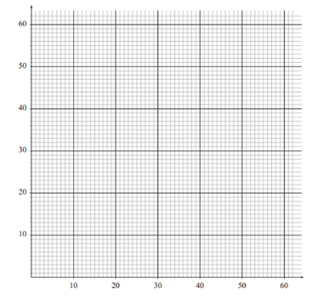

(b) Due to a change in the company, there are only 200 hours available to make the gnomes and frogs.

Investigate how this change will affect the number of each item the company should make each week in order to maximise the profit from them. Generalise how the maximum profit changes as the number of hours available decreases.

Problem 2

Andy’s confectionery shop sells sweets. Bags of wine gums and jaffas are put together in two different combinations (see table below):

Item | Amount of wine gums (grams) | Amount of jaffas (grams)
small bag (x) | 250 | 250
big bag (y) | 250 | 750
Total resources available | 180 000 | 240 000

The constraints are:

250x + 250y $≤$180 000 and 250x + 750y $≤$240 000

The revenue ($R) from the sale of the bags is given by R = 3x + 5y.

(a) Determine how many of each bag Andy should sell to maximise his revenue.

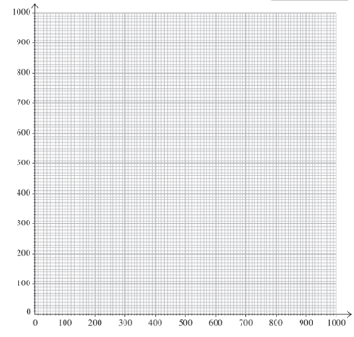

(b) Andy later decides to put 300 grams of wine gums into each of the small bags.
Explain fully the effect this decision has on the number of bags of each mixture that he should sell to maximise his revenue

Problem 3

Nicola is a farmer. The table below summarises the production data:

Item | Amount of land required (hectares) | Amount of labour required (hours)
Tonne of corn (x) | 8 | 9
Tonne of tomatoes (y) | 11 | 8
Total resources available | 440 | 360

The constraints are:

8x + 11y $≤$ 440 and 9x + 8y $≤$ 360

The income ($I) from the sale of the corn and tomatoes is given by I = 1250x + 3000y.

(a) Determine how many of tonnes of corn and tomatoes Nicola should produce to maximise her income.

(b) Nicola has found a way to decrease the labour time needed for each tonne of tomatoes, so now only 6 hours labour are needed to produce each tonne of tomatoes.

Explain fully the effect this change has on the number of tonnes of the corn and tomatoes that should be produced to maximise income.

Problem 4

Marni makes and sells two types of scented soaps. The table below shows the production data:

Item | Amount of time to make (mins) | Amount of mixture (grams)
Lavender soap (x) | 6 | 20
Mint soap (y) | 5 | 30
Total resources available | 330 | 1500

The constraints are:

6x + 5y $≤$ 330 and 20x + 30y $≤$ 1500

Her income I ($) is given by the equation I = 1.25x + 1.4y

(a) Determine how many lavender and mint soaps Marni should produce to maximise her income.
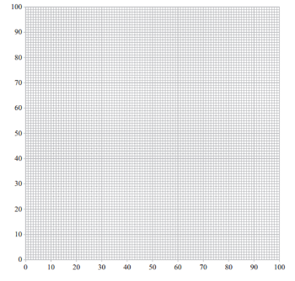

(b) A change to how the soaps are produced means that the mint soaps now take 12 minutes each to produce. Explain fully how this affects how many lavender and mint soaps Marni should produce to maximise her income.

Problem 5

A farmer has a small farm with sheep and cows. The table below summarises the farm production data:

Item | Cost of fertilizer ($)
Sheep (x) | 90
Cow (y) | 75
Total resources available | 5 400

The farmer needs to have twice the number of cows and sheep, cannot have any more than 100 animals in total.
The constraints are:

x + 2y $≤$ 100 and 90x + 75y $≤$ 5 400

The income ($I) from the animals each year is given by I = 700x + 850y.

(a) Determine how many sheep and cows the farmer should have to maximise their income.

(b) The farmer also needs to consider how they are using their land. Every sheep requires 200m² of land and every cow requires 500 m² of land. The farmer has a total of 16 000 m² available.

Explain fully how considering the land constraints affect how many sheep and cows the farmer should have to maximise their income.
.

