AS91574 Linear Programming Practice Test

Eric’s Electronics

Show ALL working

An online store called Eric’s Electronics is considering selling zPhones and zPods from their website.

Constraints
They have obtained the following information from the wholesale suppliers:

  - The storage space required for each zPhone or zPod is the same, and currently the store only has space to store a maximum of 1000 units. This can be written as x + y ≤ 1000 where x represents the number of zPhones ordered and y represents the number of zPods the store orders.

  - The wholesale price for each zPhone is $600 and the wholesale price for each zPod is $200. The shop has a budget of $320 000 to spend on their order.

  - The minimum number of zPhones they can order is 200

  - The mimimum number of zPods they can order is 400

Income
The store originally decided to sell the zPhones and zPods for the recommended selling price of $1000 for each zPhones and $400 for each zPod.

The income I ($) can be expressed as I = 1000x + 400y

Calculate how many zPhones and zPods the store should order to maximise their income.

__________________________________________________________
____________________________________________________________________________________________________________________
__________________________________________________________
____________________________________________________________________________________________________________________
__________________________________________________________
____________________________________________________________________________________________________________________
__________________________________________________________
____________________________________________________________________________________________________________________
__________________________________________________________
__________________________________________________________

Future Income
Eric does not know what the exact selling price will be for zphones and zpods in the future but it is predicted that the selling prices of zphones and zpods will be in the ratio of 3:1.

Recommend to Eric how many zphones and how many zpods he should order to maximise his profit.

You must clearly justify your answer.

__________________________________________________________
____________________________________________________________________________________________________________________
__________________________________________________________
____________________________________________________________________________________________________________________
__________________________________________________________
__________________________________________________________
__________________________________________________________
____________________________________________________________________________________________________________________
__________________________________________________________
____________________________________________________________________________________________________________________
__________________________________________________________
__________________________________________________________

AS91574 Linear Programming Exemplar Assessment Schedule

Achieved
Students are required to demonstrate at least two of the following methods.

(1) Find the equation of a linear inequality, for example, the equation for the available budget

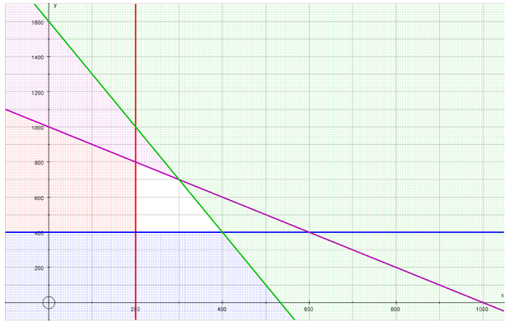
(2) Graph and shade feasible region, including labelling points where inequalities intersect (found using blue calculators or from reading off the graph on grid paper)

At least two of the constraints must be correctly shown.

(3) Calculate income for each point.

No. of zPhones (x) | No. of zPods (y) | Income($) = 1000x + 400y
200 | 800 | $520000
300 | 700 | $580000
400 | 400 | $560000
State the answer clearly in context
The store would maximise their income when they order 300 zPhones and 700 zPods.

Achieved: Parts 1 and 2 correct or parts 1 and 3 correct
Merit: Parts 1, 2 and 3 correct - including putting the answer into context
Future Income

No. of zPhones (x) | No. of zPods (y) | Income($) = 3x + y (or equivalent)
200 | 800 | $1400
300 | 700 | $1600
400 | 400 | $1600

The student identifies that there are multiple solutions for this situation in future years

The student identifies that the points (300, 700) and (400,400) both maximise the profit.
The student identifies that the linear relationship linking these two points and the future income relationship are in the same proportion.
ie. the inequality for the wholesale price 600x + 200y ≤ 320 000 has the same gradient as the income relationship P = 3x + y

Since the gradient of the inequality is the same as the gradient of the Profit equation all the whole number points along the line between this two points will also maximise the profit.

